Topic: How can consumers' psychological processes to build up brand loyalty

Abstract

Introduction
- Explain the meaning of Brand Loyalty
- Determine the importance of the Brand Loyalty influences in hospitality industry
- How do businesses enhance their brand loyalty to increased competition and its profit
- What are the benefits of enhance their brand loyalty?

Objective
- To investigate the relationship among the attitudinal brand loyalty variables (i.e., cognitive, affective, and conative brand loyalty) components to influence implicit brand loyalty and explicit brand loyalty
- To explain the significant mediating effect of cognitive, affective and conative brand loyalty in the relationship between customer satisfaction and customer delight
- To identify the importance of consumers' psychological processes in regard to developing successful brand loyalty
- To analysis contributes to the body of knowledge on customer satisfaction, delight, and loyalty and provides theoretical and applied suggestions for the hospitality industry.

Theory of Brand Loyalty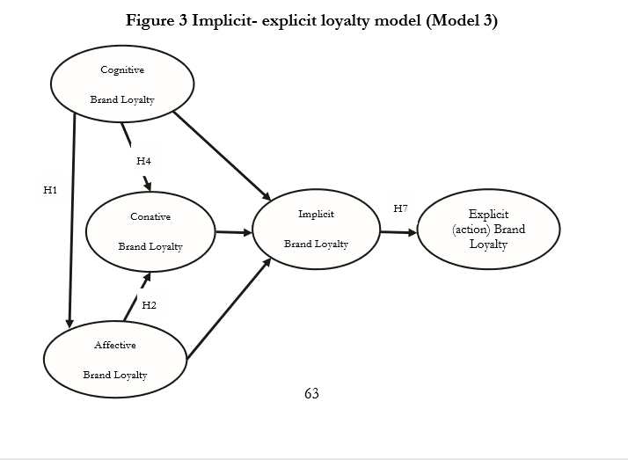
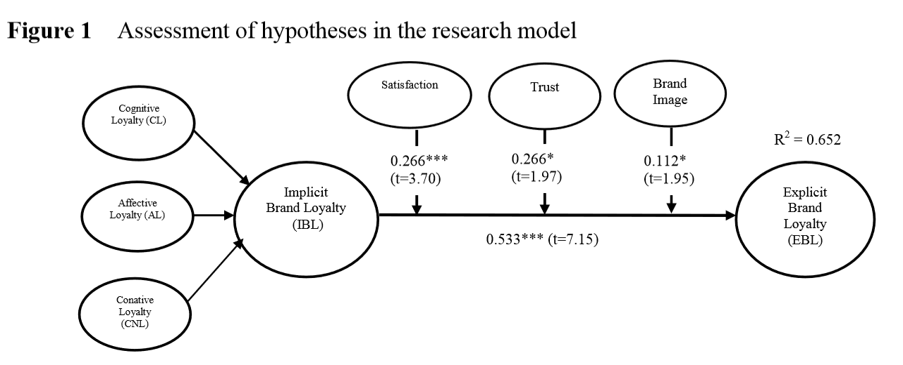
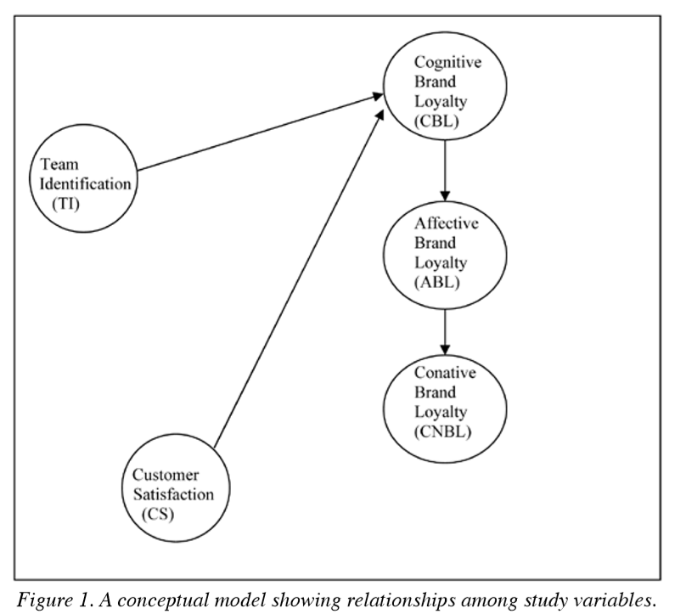

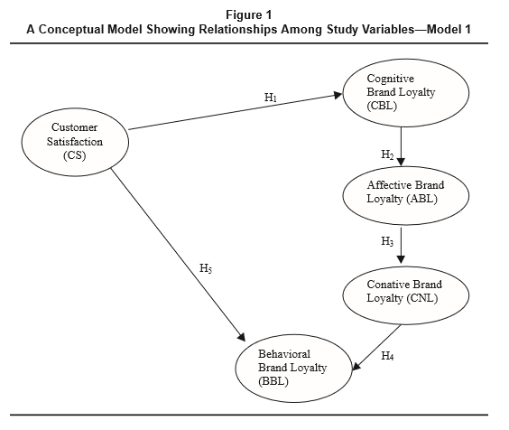
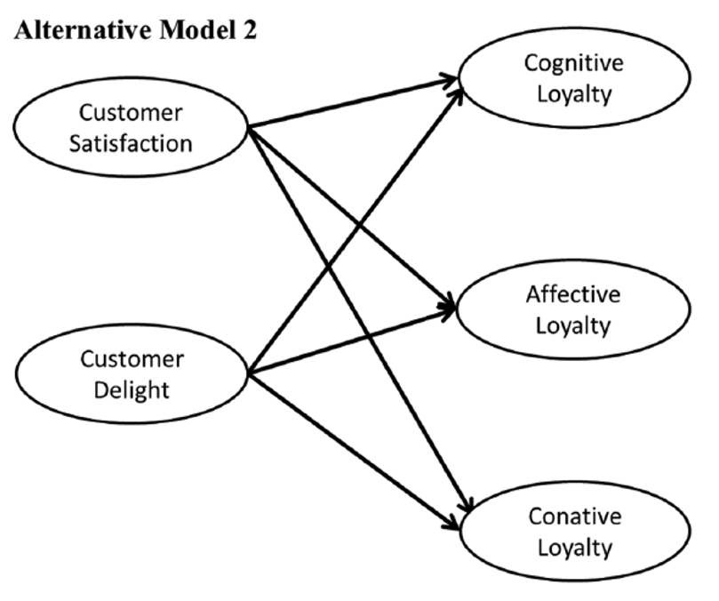

Theoretical model of this study
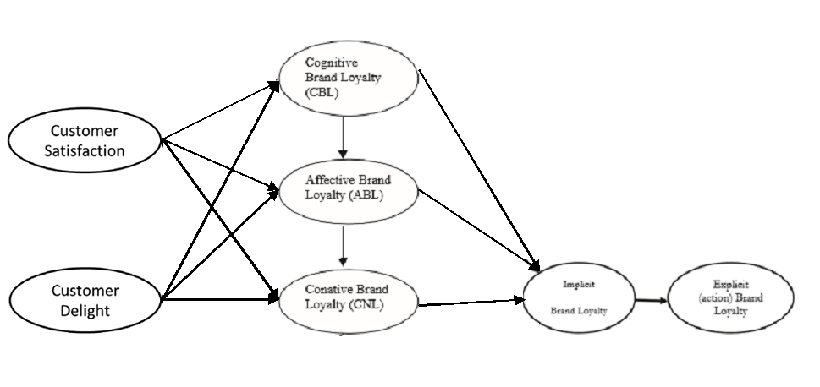

Key Concept
- Brand loyalty
- Factors
- Customer Satisfaction
- Customer Delight
- Cognitive Brand Loyalty
- Conative Brand Loyalty
- Affective Brand Loyalty
- Implicit Brand Loyalty
- Explicit (Action) Brand Loyalty

Development of a theoretical framework
- Explain the relationship of the above factors
- How to affect the Brand loyalty
- The final outcome, Brand Loyalty and explain

Best Practice
- Hospitality industry brands that success to apply this theory on their brand building
- What they do to enhance the brand loyalty (app, member VIP)

Conclusion
Summary
Important factors to consider in developing a brand loyalty
(Based on the best practice)

Limitation and further research
Based on the sourcing/ reference

